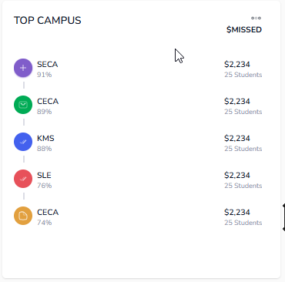
http://localhost:8080/api/attendance/getCampusAda
Request: {}
Response: [
{
"numberStudentAbsent": 1989,
"campusName": "ECHS",
"estimatedMissedFinance": 109395.00,
"averageAdaPct": 96.20168
},
{
"numberStudentAbsent": 3077,
"campusName": "CE",
"estimatedMissedFinance": 169235.00,
"averageAdaPct": 95.042372
}]
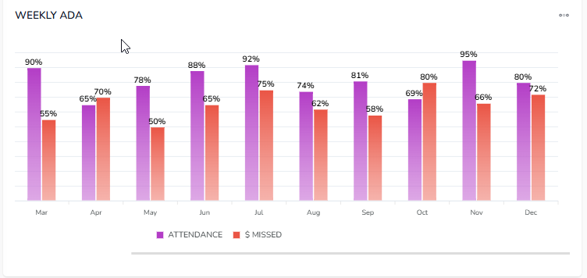
http://localhost:8080/api/attendance/getMonthlyAda
{}
Response: [
{
"month": "August-2024",
"estimatedMissedFinance": 331265.00,
"averageAdaPct": 95.916201
},
{
"month": "September-2024",
"estimatedMissedFinance": 577610.00,
"averageAdaPct": 94.679824
}
]
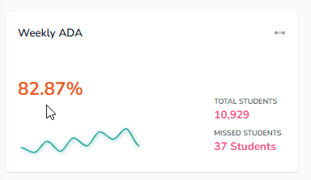
http://localhost:8080/api/attendance/getAda
{}
Response: {
"allAda": [
95.916201,
94.679824,
94.680555,
93.684523,
93.888888,
92.888888,
93.117647,
93.097222
],
"totalStudents": 1208541,
"noStudentAbsents": 72907,
"averageAdaPct": 94.088997
}
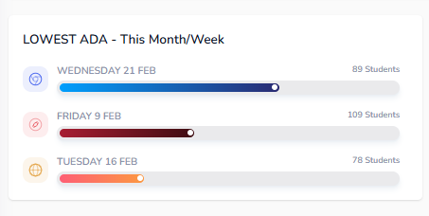
http://localhost:8080/api/attendance/getLowestAda
{}
Resnpose: [
{
"date": "03-Mar-2025",
"campusName": "KHS",
"totalAbsencePerCampus": 594,
"noOfStudentAbsence": 204,
"day": "Monday"
},
{
"date": "04-Mar-2025",
"campusName": "KHS",
"totalAbsencePerCampus": 594,
"noOfStudentAbsence": 169,
"day": "Tuesday"
},
{
"date": "04-Mar-2025",
"campusName": "KMS",
"totalAbsencePerCampus": 507,
"noOfStudentAbsence": 143,
"day": "Tuesday"
}
]
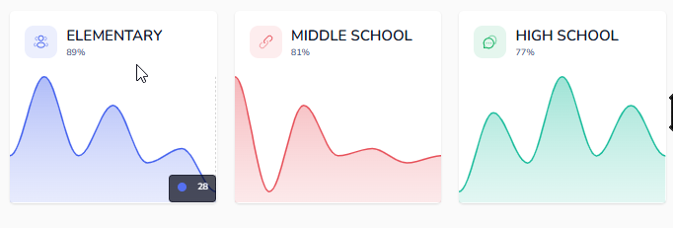
http://localhost:8080/api/attendance/getSchoolAda
{}
Response:
{
"HIGHSCHOOL": [
96.155555,
94.754385,
94.648148,
93.666666,
94.577777,
93.377777,
93.705882,
92.941176
],
"EARLYCHILDHOODACADEMY": [
93.9,
91.947368,
93.083333,
91.464285,
90.6,
91.0,
90.352941,
89.76923
],
"MIDDLESCHOOL": [
96.1,
95.131578,
95.138888,
94.285714,
94.333333,
93.8,
93.558823,
94.272727
],
"ELEMENTARYSCHOOL": [
96.513513,
95.547368,
95.155555,
94.342857,
94.613333,
92.986666,
93.694117,
94.16129
]
}

